Experience, Learn, & Earn (ELE) Program toolkit: social media posts and website copy

The AICPA and NASBA launched an integrated education and experience program for students who need or want a path to the 150 credit hours of education required for CPA licensure, that allows them to earn up to 30 educational credit hours while they are employed with a CPA firm and earning a living. The ELE combines meaningful online academic coursework integrated with work experience.

Use the suggested social media posts and website copy below or create your own posts using the hashtag #.

Link to more information: https://experiencelearnearn.org/Index.html

Graphics

Ready-made images for LinkedIn and Facebook:

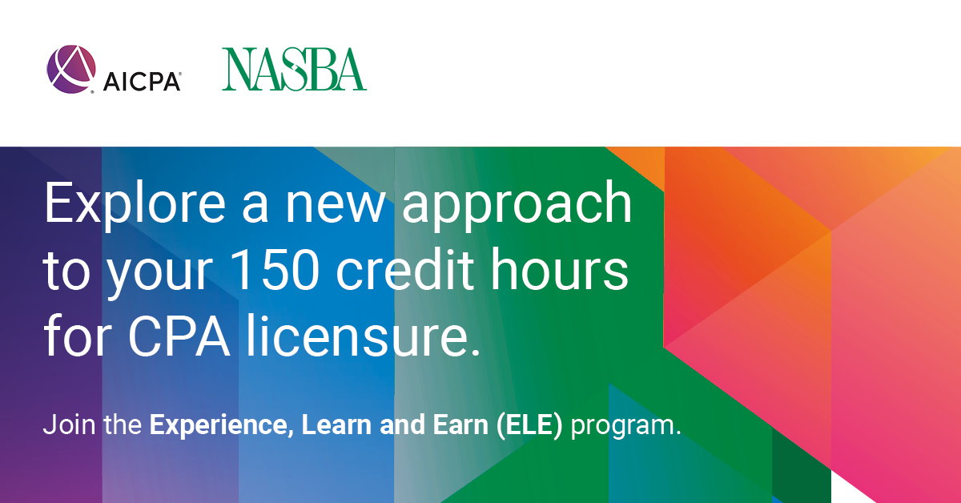

Suggested social media/newsletter posts
Earn your CPA license while gaining valuable work experience with the Experience, Learn, and Earn program.

Want a flexible, balanced approach on your path to becoming a CPA? Explore the Experience, Learn, and Earn program.
Advance your career and earn a paycheck at the same time with the Experience, Learn, and Earn program.

Want to put your accounting degree to work? Enroll in our Experience, Learn, and Earn program to advance your career.

Suggested website copy:
We are participating in the American Institute of CPAs® (AICPA®) and the National Association of State Boards of Accountancy (NASBA) integrated experience, education, and earning education and experience program to support students and new hire employees like you in your journey to CPA.

Experience, Learn and Earn (ELE)
The ELE route enables you to earn up to 30 of your 150 credit hours of education for a CPA licensure.

You will:
- Start the ELE program by attending online and asynchronous courses with Tulane University’s School of Professional Advancement.
- Have the opportunity to earn credit hours in the areas relevant to your career while being employed in an accounting position with us.
- Receive regular mentoring, time to study and be able to learn and apply the knowledge to your career.

How it works
After completing your bachelor’s degree and core accounting courses, you can enroll in the program. This program is flexible to the number of credit hours you need and is offered at an affordable rate.

To learn more about how you can join our firm and become eligible for the ELE program, please contact:

Program brochure:

Customize this program overview with your firm’s name, logo and contact details.

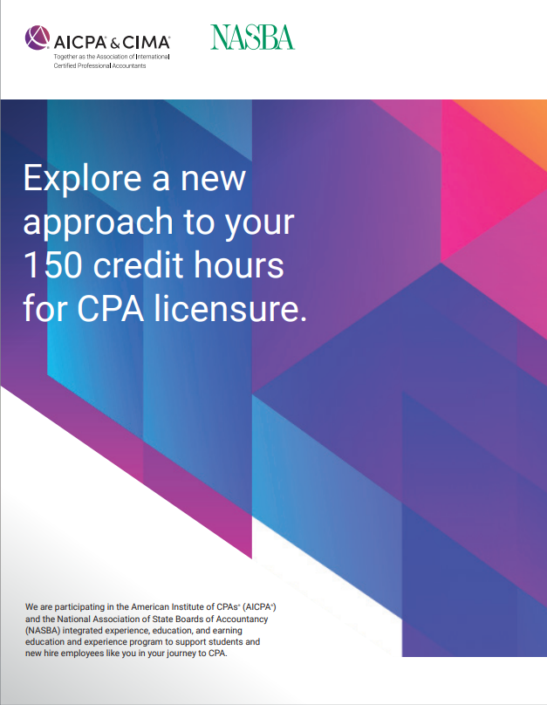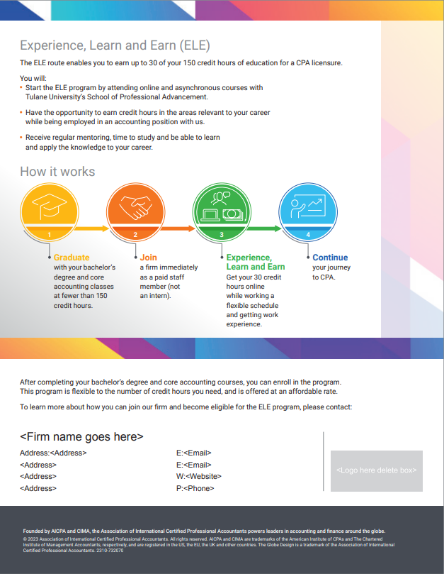
Front Back

